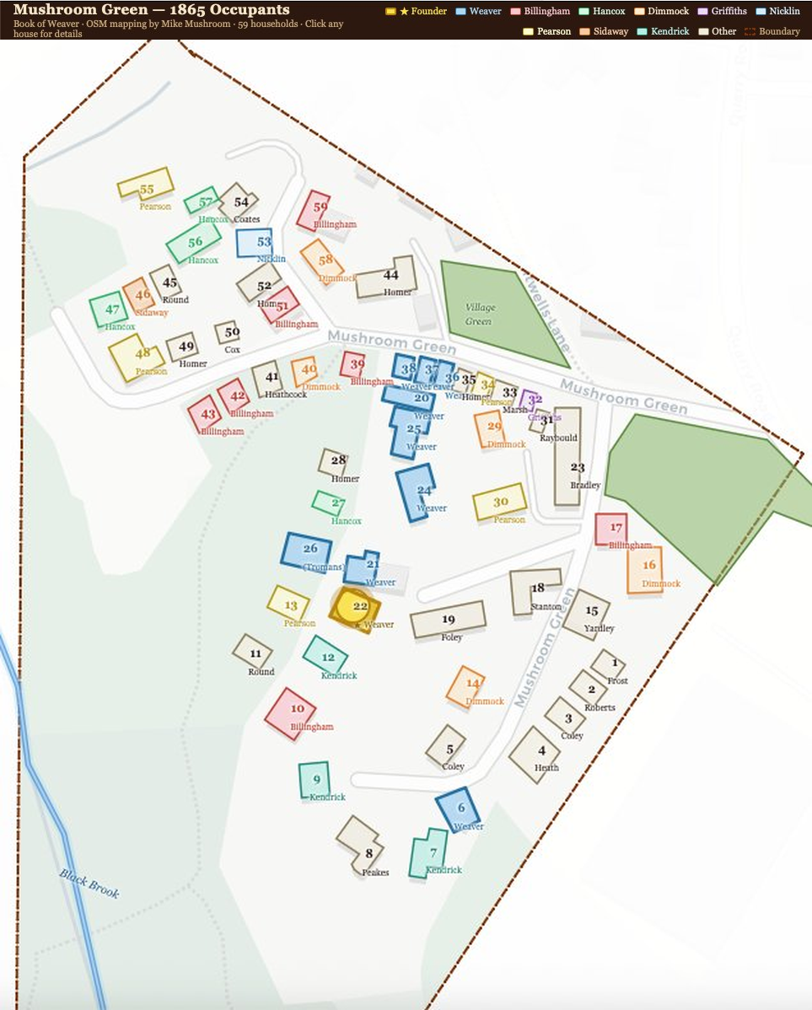
Mushroom Green c.1860 — household map based on 1861 census returns
An interactive version of this map is available. Keep the file below in the same folder as this document, then open it in any web browser:
mushroom_green_1865_v10_10.html

